
HEALTH, SAFETY & ENVIRONMENT MANAGEMENT SYSTEM
DAN Construction Safety Manual (DCSM)
Concrete and Masonry Construction

Document Control
Document No. | 01-000001-000000-DAN-HSE-PRC-000045 | Revision | R01
Issue Date | June 2026 | Classification | Controlled — Internal
Document Owner | HSE Department | Page Format | US Letter

Table of Contents

1. Purpose
2. Scope
3. References
4. Definitions
5. General Requirements
6. Formwork
7. Cast-In-Place Concrete
8. Precast Concrete, Lift-Slab and Jacking
9. Concrete Placement Equipment
10. Prestressed Concrete
11. Masonry
12. Periodic Inspections / Records
13. Related Documents
Figures and Illustrations
Revision History

1. Purpose
This document provides the requirements for concrete and masonry construction work on DAN projects, including formwork, cast-in-place and precast concrete, prestressing/post-tensioning and masonry.

2. Scope
This document applies to all concrete and masonry construction on DAN projects — formwork and shoring, reinforcing steel, concrete placement and equipment, precast/lift-slab operations, prestressed concrete and masonry walls.

3. References
- 29 CFR 1926 Subpart Q — Concrete and Masonry Construction; 29 CFR 1926.55
- ANSI/ASSE A10.9 — Masonry and Concrete Work; EM 385-1-1, Section 27.G.02
- ACI 347, ACI 347.2R, ACI SP-4; ASCE 37
- DCSM — Fall Protection and Prevention; DCSM — Scaffolding; DCSM — Lockout / Tagout; DCSM — Hazard Communication

4. Definitions
Term | Definition
Formwork | The total system of support for freshly placed concrete, including the mould, hardware, shoring and bracing.
Shoring / Reshoring | Temporary vertical supports for formwork; reshoring supports stripped concrete that must carry loads beyond its capacity.
Lift-Slab Operation | Casting slabs at grade and jacking them up columns into final position.
Limited Access Zone | A restricted zone established alongside a masonry wall under construction.
Degreed Structural Engineer | A qualified engineer who designs/verifies formwork, bracing and structural capacity.

5. General Requirements
- The Contractor shall prepare a method statement for the structure, including all steps and precautions to ensure personnel safety at every stage; all activities shall be supervised by a competent person knowledgeable in the work and its hazards.
- Personnel working above 6 ft (1.83 m) shall have a guardrail-protected platform or wear a full-body harness and shock-absorbing lanyard attached to a lifeline/anchorage (see the Fall Protection chapter).
- No construction loads shall be placed on a concrete/masonry structure unless the Contractor (verified by a degreed structural engineer) determines it can support them; bulk storage bins/silos shall have conical/tapered bottoms with mechanical/pneumatic flow initiation.
- Maintenance/repair on concrete equipment (compressors, mixers, screens, pumps) shall not be performed unless hazardous energy is isolated per the Lockout/Tagout chapter; guards shall be erected around protruding reinforcing steel against falls/impalement.
- During tensioning, only authorised personnel are permitted behind the jack; personnel shall not ride in or work under elevated concrete buckets; a concrete washout pit shall be provided and wash water shall not drain to public sewers unless properly treated.
PPE: rubber shoes for concrete pouring shall have toe protection, and head/face protection shall be worn when applying cement/sand/water mixtures through a pneumatic hose.

6. Formwork
- Formwork shall be designed, erected, supported, braced and maintained per ACI 347/347.2R, ACI SP-4, ANSI/ASSE A10.9 and ASCE 37; shoring of scaffolding materials supporting a slab/deck more than 12 in (30 cm) thick shall be classified a "special scaffold".
- Drawings and structural calculations for all elevated formwork shall be prepared and approved by a degreed structural engineer and available on-site; a minimum safety factor of four against failure shall be used for tubular steel formwork shoring.
- Fabricated tubular frame scaffolding shall not be used for formwork (unless specifically designed and permitted); shoring of scaffolding materials shall be erected under the on-site supervision of a third-party-certified Scaffold Supervisor, with sound, rigid sills.
- Formwork materials shall be inspected for defects before erection and tagged after erection; shoring shall be plumb to within 1/8 in per 3 ft (3 mm per 1 m); damaged/weakened formwork shall be immediately reinforced or reshored.
- Personnel are not allowed under or near formwork during pours; stripped forms shall be stockpiled promptly with protruding nails bent/removed; concrete/materials shall not be placed on partially completed formwork.
6.1 Tube-and-Coupler, Single-Post and Slip-Form Shoring
- Couplers shall not be used if deformed, broken or with defective threads; all formwork tubing shall be embossed/certified; base plates, shore heads, extension devices and screw jacks shall be in firm contact with the sill and form materials.
- Single-post shores shall be horizontally and diagonally braced in both directions as erected, never stacked vertically; tiered or sloping single-post shoring requires a layout drawing approved by, and inspection by, a degreed structural engineer before concrete placement.
- For vertical slip forms, the rods/pipes shall be designed for the purpose and braced where not encased; jacks shall be placed so loads are distributed equally within capacity, fitted with automatic holding devices; lateral/diagonal bracing shall prevent distortion, and the form kept plumb during jacking, with an encircling work platform.
6.2 Reinforcing Steel and Silica
- All protruding reinforcing steel onto which personnel could fall shall be guarded against impalement; personnel shall not work above vertical protruding rebar unless bent over or capped; vertical formwork rebar shall be braced against collapse and wind loads; wire-mesh rolls shall be secured at each end against recoil.
- The Site SH&E Representative shall ensure AHAs are conducted for silica-generating activities (jack-hammering, mixing, drilling, brick/block cutting) and determine controls — hazard-communication training, engineering/administrative controls (local exhaust ventilation, water sprays), washable clothing/washing facilities, and exposure monitoring/health screening.

7. Cast-In-Place Concrete
- Tiered single-post shores shall be vertically aligned, spliced against misalignment and braced in two perpendicular directions at the splice and each tier; single-post shores shall not be adjusted after concrete is placed; reshoring shall be erected as forms/shores are removed where concrete must carry loads beyond its capacity.
- Forms and shores (except slab-on-grade and slip forms) shall not be removed until the project engineer determines the concrete has gained sufficient strength — per the plans/specifications or ASTM-standard concrete testing.
- Bull-float handles that may contact energised conductors shall be non-conductive; manually guided powered troweling machines shall have a "dead-man" control that shuts off power when the operator's hands leave the handles, with guarded blades.

8. Precast Concrete, Lift-Slab and Jacking
- Lift-slab operations shall be planned/designed by the Project Engineer with provisions for lateral stability; only personnel essential to the jacking operation are permitted in the structure, and none beneath a slab being lifted.
- Precast members shall be cast/handled/erected under a qualified person, stored to prevent tipping on a level base, handled at designated lifting points with compatible attachments, and braced until permanent connections are complete (temporary bracing designed for at least 15 lb/ft² / 0.7 kN/m²).
- Lifting hardware shall have a minimum safety factor of 5; lifting inserts in tilt-up members a factor of 2, and in other precast members a factor of 4; jacking equipment shall support at least 2½ times the load being lifted.
- A maximum of 14 manually controlled jacks are permitted on one slab; jacking shall be synchronised, all slab support points kept within 1/2 in (1.27 cm) of level, and jacking equipment inspected by a qualified person immediately before daily operations; personnel shall not stand in line with or over jacking equipment during tensioning.

9. Concrete Placement Equipment
- Loading skips of 1 yd³ (0.75 m³) or larger shall have a mechanical clearing device; mixers of that capacity shall additionally have guardrails on each side of the skip; concrete buckets with hydraulic/pneumatic gates shall have positive safety latches against premature dumping.
- Pump-crete discharge pipes shall have supports designed for 100% overload (safety factor of two), hose joints with positive locking and a safety chain/pin, outriggers with pads at least three times the float area, and shall maintain minimum clearances from overhead power lines.
- Personnel shall not ride in/on concrete buckets or work under them while being raised/lowered; vibrator crews shall not stand under elevated buckets; concrete-buggy handles shall not extend beyond the wheels and shall have knuckle guards.
- Ready-mix truck wheels shall be blocked and brakes set; a spotter shall be used when backing; eye-flushing equipment shall be available wherever concrete is mixed/poured/finished; polyethylene sheets shall collect displaced concrete, and truck tyres cleaned before leaving site.

10. Prestressed Concrete
- Field operations shall be under a qualified person; personnel involved in prestressing/post-tensioning shall be instructed in safe procedures and wear eye protection during grouting, stressing and cable trimming.
- Visual/audible signalling devices shall warn personnel approaching tensioning operations; signs, signals and barriers shall keep personnel from behind the jack/anchor plates, and guards shall contain flying strands in the event of failure; non-essential personnel shall be kept clear.
- Operators shall be given the maximum allowable tendon stretch and hydraulic pressure; significant deviations require stopping and consulting the site engineer; jack pressure gauges shall be checked against a master gauge and calibration charts furnished.
- Tendons shall be stored/handled to prevent rust, nicks or kinks, kept clean, cut only with shears or high-speed abrasive wheels, and protected from welding/cutting sparks and stray current; anchor fittings shall follow the manufacturer's instructions, and strand couplers shall be inspected before reuse.

11. Masonry
- Masonry construction shall be under a qualified person, with units stored on firm, level support and scaffold rated capacity not exceeded; loose bricks shall not be stacked above 7 ft (2.1 m) and shall be tapered back 2 in per 1 ft above 4 ft; loose blocks above 6 ft (1.83 m) shall be tapered back one-half block height per tier.
- Masonry walls over 8 ft (2.4 m) shall be shored/braced until the designed lateral strength is reached (bracing designed for at least 15 lb/ft² / 0.7 kN/m²); masonry saws shall be guarded by a semicircular enclosure (maximum 180° blade exposure).
- A limited access zone shall be established before wall construction, at a distance equal to the wall height plus 4 ft (1.2 m) along the full wall length, on any side the wall could overturn, restricted to personnel actively building the wall, and kept until the wall is adequately supported; scaffolds shall not provide temporary lateral support for masonry walls.

12. Periodic Inspections / Records
The designated person inspects shoring before erection (against the shoring design), and the erected shoring immediately before, during and after concrete placement; damaged, displaced or weakened shoring shall be reinforced or reshored immediately. Method statements, formwork drawings/calculations and approvals, inspection records and training records shall be maintained on-site and archived at project close.

13. Related Documents
- DCSM — Fall Protection and Prevention
- DCSM — Scaffolding
- DCSM — Lockout / Tagout
- DCSM — Hazard Communication

Figures and Illustrations
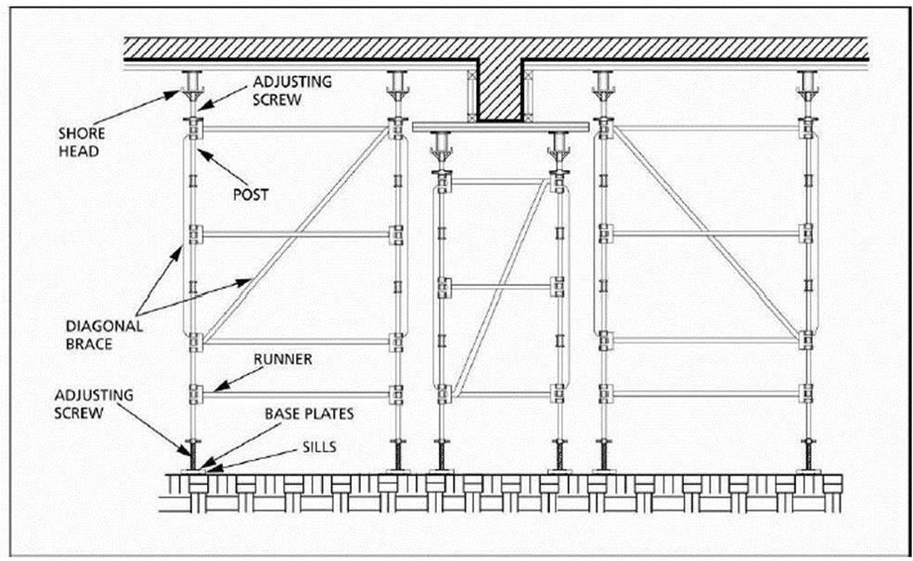
Figure 45-1 System Scaffolding / Formwork / Shoring
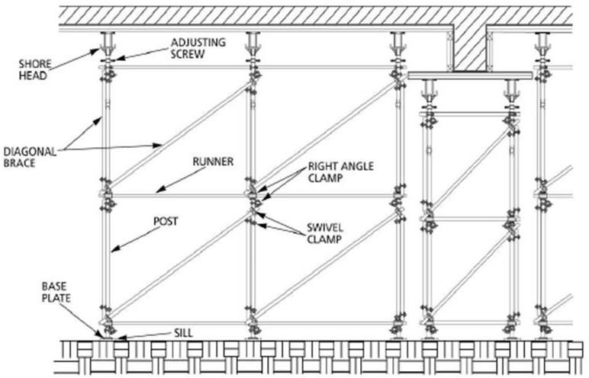
Figure 45-2 Tube and Coupler Formwork Shoring
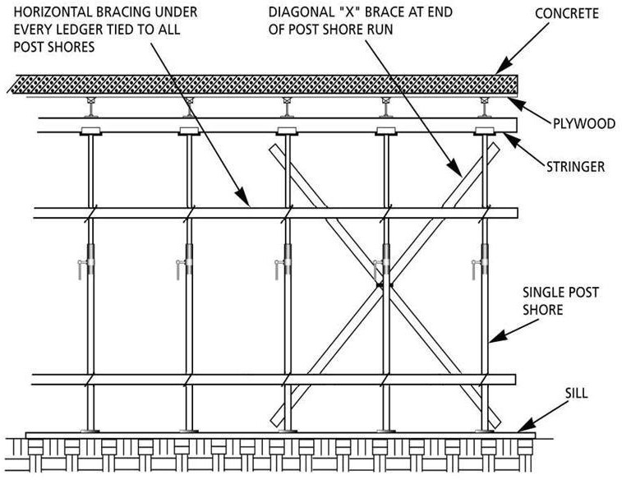
Figure 45-3 Single Post Shores

Revision History
Rev. | Date | Description of Change | Approved By
R00 | June 2026 | Initial issue. Restructured to the DAN integrated HSSE management-system template and re-branded in accordance with the DAN Brand Book. | Project Director
R01 | June 2026 | Re-coded to the updated DAN document-numbering convention (01-000001-000000-DAN-{discipline}-{type}-{seq}). | Project Director

